Pay It Forward
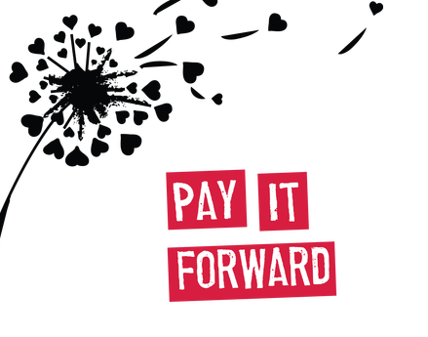

Dear Parents,
This year in 6th grade, your student will have an opportunity to take part in a memorable and fulfilling activity titled Pay It Forward. I started this service activity with my sixth graders last year. With much success, we were able to touch the lives of hundreds as we gave back within our community. The Pay It Forward program is designed to allow students to give back to local organizations within our community. This year we will give back to four organizations, LeBonheur Children’s Research Hospital, Memphis Union Mission, Germantown Police and Fire Departments, and St. Jude Children’s Research Hospital! Each nine weeks, I will send home a letter that contains information about the organization, dates of collection, and the items the organization is seeking. Students participating in the Pay It Forward after school club will pack the items and create crafts.
“Gifts aren’t meant to be paid back, they are to be paid forward.” Cedric Crawford

Child’s name _______________________________
______ Yes, my child can bring in donated items to Pay It Forward
______ No, my child cannot bring items (Your child’s grade will not be affected)
Parent volunteer: If you can come in afterschool to help pack, please let me know on the line below.
______ I would like to come in to help with the packing after school

